/*

* Justin Mendes

* December 24, 2016

* Unit 4 Activity 4 Program/Question 1

* This program will make the user input a number that corresponds to an element in the game Rock,Paper,Scissors and the computer will randomly make a move against the user

*/

**import** java.io.BufferedReader;

**import** java.io.IOException;

**import** java.io.InputStreamReader;

**public** **class** RockPaperScissors

{

**static** String *outcome*;

**static** **int** *computerMove*, *wins* = 0, *losses* = 0, *ties* = 0;

**public** **static** **void** main(String[] args) **throws** NumberFormatException, IOException

{

//Variable Declarations and Initializations

**int** restart = 1, userMove = 0;

BufferedReader br = **new** BufferedReader (**new** InputStreamReader (System.***in***));

**while**(restart == 1)

{

//to restart computer's randomization each time

*computerMove* = 0;

System.***out***.println("ROCK PAPER SCISSORS\n================\n");

System.***out***.println("1 = Rock\n2 = Paper\n3 = Scissors\n=============\nChoose:");

userMove = Integer.*parseInt*(br.readLine());

//checks if the user input is valid, Exception Handling.

**while**(userMove > 3 || userMove < 1)

{

System.***out***.println("INVALID input...\n1 = Rock\n2 = Paper\n3 = Scissors\nInput a whole number from 1-3:");

userMove = Integer.*parseInt*(br.readLine());

}//end loop

*randomWholeNumber*();

*determineOutcome*(userMove);

System.***out***.println("Press 1 to play again.");

restart = Integer.*parseInt*(br.readLine());

}//end loop

}//end main

**public** **static** **int** randomWholeNumber()

{

**while** (*computerMove* > 3 || *computerMove* < 1)

{

*computerMove* = (**int**) ((Math.*random*() * 3) + 1);

}//end loop

**return** (*computerMove*);

}//end method randomWholeNumber

**public** **static** **void** determineOutcome(**int** userMove)

{

**if**(userMove == *computerMove*)

{

**if**(userMove == 1)

{

System.***out***.println("You have chosen Rock.\nThe computer has chosen Rock.\n\nIt's a tie!");

}//end if

**else** **if**(userMove == 2)

{

System.***out***.println("You have chosen Paper.\nThe computer has chosen Paper.\n\nIt's a tie!");

}//end if

**else**

{

System.***out***.println("You have chosen Scissors.\nThe computer has chosen Scissors.\n\nIt's a tie!");

}//end if

*ties* += 1;

}//end if

**else** **if**(userMove == 1)

{

**if**(*computerMove* == 3)

{

System.***out***.println("You have chosen Rock.\nThe computer has chosen Scissors.\n\nRock breaks Scissors. You win!");

*wins* += 1;

}//end if

**else**

{

System.***out***.println("You have chosen Rock.\nThe computer has chosen Paper.\n\nRock gets covered by Paper. You lose.");

*losses* += 1;

}//end else

}//end else if

**else** **if** (userMove == 2)

{

**if**(*computerMove* == 1)

{

System.***out***.println("You have chosen Paper.\nThe computer has chosen Rock.\n\nPaper covers Rock. You win!");

*wins* += 1;

}//end if

**else**

{

System.***out***.println("You have chosen Paper.\nThe computer has chosen Scissors.\n\nPaper gets cut by Scissors. You lose.");

*losses* += 1;

}//end else

}//end else if

**else** **if** (userMove == 3)

{

**if**(*computerMove* == 2)

{

System.***out***.println("You have chosen Scissors.\nThe computer has chosen Paper.\n\nScissors cuts Paper. You win!");

*wins* += 1;

}//end if

**else**

{

System.***out***.println("You have chosen Scissors.\nThe computer has chosen Rock.\n\nScissors gets smashed by Rock. You lose.");

*losses* += 1;

}//end else

}//end else if

System.***out***.println("WINS: " + *wins* + "\nLOSSES: " + *losses* + "\nTIES: " + *ties*);

}//end method determineOutcome

}//end class

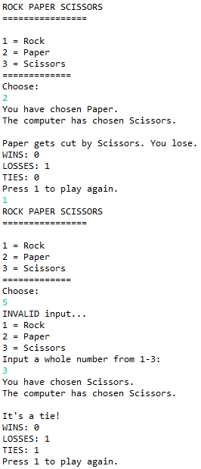

/*

* Justin Mendes

* December 25, 2016

* Unit 4 Activity 4 Program/Question 2

* This program will have the user guess three random colors that the computer chooses (out of 4 colors) and compares the user guess to the computer

*/

**import** java.io.BufferedReader;

**import** java.io.IOException;

**import** java.io.InputStreamReader;

**public** **class** GuessColourBlocks

{

**static** **int** *computerGuess*;

**static** String *computerColour*;

**public** **static** **void** main(String[] args) **throws** IOException

{

//Variable Declarations and Initializations

**int** restart = 1;

String firstGuess, secondGuess, thirdGuess;

BufferedReader br = **new** BufferedReader (**new** InputStreamReader (System.***in***));

**while** (restart == 1)

{

//to restart the values

**int** colourCorrect = 0, positionCorrect = 0;

String guess;

System.***out***.println("Guess the Blocks\n=================\n");

System.***out***.println("In this game, there are four different coloured blocks (red, green, blue, and yellow).\nThe computer hides three different coloured blocks from you. You then try to\nguess the colours and the order of the blocks.");

System.***out***.println("\nEnter your first guess (R, G, B, Y):");

firstGuess = br.readLine();

**while** (!firstGuess.equals("R") && !firstGuess.equals("G") && !firstGuess.equals("B") && !firstGuess.equals("Y"))

{

System.***out***.println("Invalid input...\nEnter your first guess (R, G, B, Y):");

firstGuess = br.readLine();

}//end loop

System.***out***.println("\nEnter your second guess (R, G, B, Y):");

secondGuess = br.readLine();

**while** (!secondGuess.equals("R") && !secondGuess.equals("G") && !secondGuess.equals("B") && !secondGuess.equals("Y"))

{

System.***out***.println("Invalid input...\nEnter your second guess (R, G, B, Y):");

secondGuess = br.readLine();

}//end loop

System.***out***.println("\nEnter your third guess (R, G, B, Y):");

thirdGuess = br.readLine();

**while** (!thirdGuess.equals("R") && !thirdGuess.equals("G") && !thirdGuess.equals("B") && !thirdGuess.equals("Y"))

{

System.***out***.println("Invalid input...\nEnter your third guess (R, G, B, Y):");

thirdGuess = br.readLine();

}//end loop

guess = firstGuess + " " + secondGuess + " " + thirdGuess + " ";

System.***out***.println("Your Guesses: " + guess);

//to restart the random computer string every "try again"

*computerColour* = "";

**for** (**int** i = 0; i < 3; i++)

{

//to restart the randomization

*computerGuess* = 0;

*randomWholeNumber*();

**switch** (*computerGuess*)

{

**case** 1: *computerColour* = *computerColour* + "R ";

**break**;

**case** 2: *computerColour* = *computerColour* + "G ";

**break**;

**case** 3: *computerColour* = *computerColour* + "B ";

**break**;

**default**: *computerColour* = *computerColour* + "Y ";

**break**;

}//end switch

}//end loop

System.***out***.println("Comp Guesses: " + *computerColour*);

colourCorrect = *checkColoursCorrect*(guess, colourCorrect);

positionCorrect = *checkPositionsCorrect*(guess, positionCorrect);

System.***out***.println("\nNumber of Colours Correct = " + colourCorrect);

System.***out***.println("Number of Positions Correct = " + positionCorrect);

System.***out***.println("\nEnter 1 to try again.");

restart = Integer.*parseInt*(br.readLine());

}//end loop

}//end main

**public** **static** **int** checkColoursCorrect(String guess, **int** colourCorrect)

{

**if**(guess.contains(*computerColour*.substring(0, 1)))

{

colourCorrect += 1;

}//end if

**if**(guess.contains(*computerColour*.substring(2, 3)))

{

colourCorrect += 1;

}//end if

**if**(guess.contains(*computerColour*.substring(4, 5)))

{

colourCorrect += 1;

}//end if

**return** colourCorrect;

}//end method checkColoursCorrect

**public** **static** **int** checkPositionsCorrect(String guess, **int** positionCorrect)

{

**if**(guess.substring(0, 1).equals(*computerColour*.substring(0, 1)))

{

positionCorrect += 1;

}//end if

**if**(guess.substring(2, 3).equals(*computerColour*.substring(2, 3)))

{

positionCorrect += 1;

}//end if

**if**(guess.substring(4, 5).equals(*computerColour*.substring(4, 5)))

{

positionCorrect += 1;

}//end if

**return** positionCorrect;

}//end method checkPositionsCorrect

**public** **static** **int** randomWholeNumber()

{

**while** (*computerGuess* > 4 || *computerGuess* < 1)

{

*computerGuess* = (**int**) ((Math.*random*() * 4) + 1);

}//end loop

**return** (*computerGuess*);

}//end method randomWholeNumber

}//end class

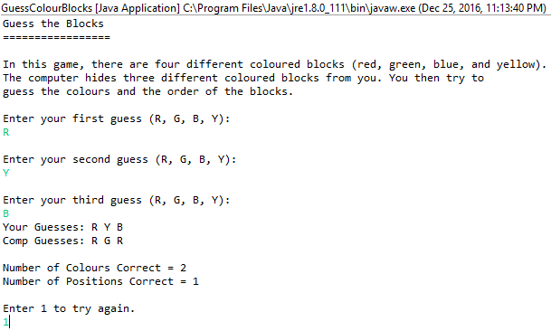

/*

* Justin Mendes

* December 25, 2016

* Unit 4 Activity 4 Program/Question 3

* This program will make the user play a guessing game with the computer's random number

*/

**import** java.io.BufferedReader;

**import** java.io.IOException;

**import** java.io.InputStreamReader;

**public** **class** GuessNumber

{

**static** **int** *computerGuess*, *userGuess*, *goal*;

**public** **static** **void** main(String[] args) **throws** NumberFormatException, IOException

{

//Variable Declarations and Initializations

**int** lowVal, highVal, restart = 1;

BufferedReader br = **new** BufferedReader (**new** InputStreamReader (System.***in***));

**while** (restart == 1)

{

//to restart the values

*computerGuess* = 0;

System.***out***.println("Guess the Number\n=================\n");

System.***out***.println("In this game, you will set the range for the numbers to guess between and the computer\nwill generate a random number in this range. Then you\nwill try to guess the number before the number of guesses you set.");

System.***out***.println("\nInput the low value of your range:");

lowVal = Integer.*parseInt*(br.readLine());

System.***out***.println("\nInput the high value of your range:");

highVal = Integer.*parseInt*(br.readLine());

System.***out***.println("\nSet a number of guesses you cannot exceed:");

*goal* = Integer.*parseInt*(br.readLine());

*randomWholeNumber*(lowVal, highVal);

System.***out***.println("The computer has generated a random number between " + lowVal + " and " + highVal + ".\n");

*userGuess* = 0;

**for**(**int** i = 0; *userGuess* != *computerGuess*; i++)

{

*guessProcess*(i + 1, br);

*guessChecker*(i + 1, lowVal, highVal, br);

**if**(*goal* == i + 1)

{

*userGuess* = *computerGuess*;

}//end if

}//end loop

System.***out***.println("\nPress 1 to try again.");

restart = Integer.*parseInt*(br.readLine());

}//end loop

}//end main

**public** **static** **int** randomWholeNumber(**int** lowVal, **int** highVal)

{

**while** (*computerGuess* > highVal || *computerGuess* < lowVal)

{

*computerGuess* = (**int**) ((Math.*random*() * highVal) + lowVal);

}//end loop

**return** (*computerGuess*);

}//end method randomWholeNumber

**public** **static** **void** guessProcess(**int** i, BufferedReader br) **throws** NumberFormatException, IOException

{

System.***out***.println("Guess #" + i + "\n=============");

System.***out***.println("You have " + (*goal* - i + 1) + " guess(es) left.");

System.***out***.println("Input your guess:");

*userGuess* = Integer.*parseInt*(br.readLine());

}//end method guessProcess

**public** **static** **void** guessChecker(**int** i, **int** lowVal, **int** highVal, BufferedReader br) **throws** NumberFormatException, IOException

{

**if**(i == *goal* && *userGuess* != *computerGuess*)

{

System.***out***.println("You didn't guess in the set number of tries.\nThe computer was thinking of the number " + *computerGuess*);

}//end if

**else**

{

//checks if the guess is within the range

**while** (*userGuess* < lowVal || *userGuess* > highVal)

{

System.***out***.println("Remember you want to guess as little as possible!\nGuess again within the range of " + lowVal + " and " + highVal + ":");

*userGuess* = Integer.*parseInt*(br.readLine());

}//end loop

**if**(*userGuess* > *computerGuess*)

{

System.***out***.println("You have guessed Higher, try a LOWER number.\n");

}//end if

**else** **if** (*userGuess* < *computerGuess*)

{

System.***out***.println("You have guessed Lower, try a HIGHER number.\n");

}//end else if

**else**

{

System.***out***.println("\nAfter guess #" + i + ", you got the number right!\nThe computer was thinking of the number " + *computerGuess* + "!");

}//end else

}//end else

}//end method guessChecker

}//end class

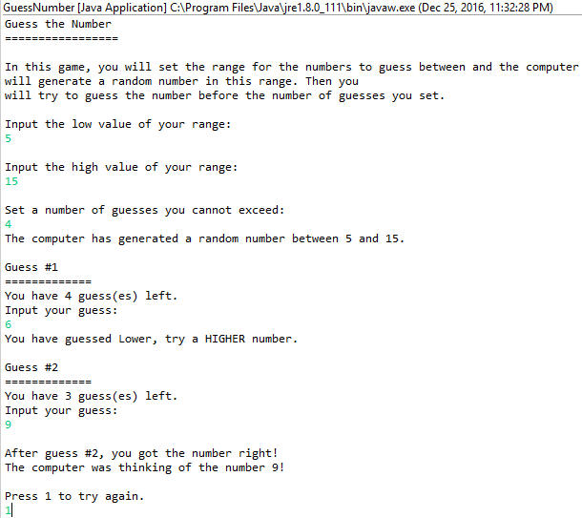

/*

* Justin Mendes

* Unit 4 Activity 4 Program/Question 4

* December 25, 2016

* This program will reduce a fraction to it's lowest terms

*/

**import** java.io.BufferedReader;

**import** java.io.IOException;

**import** java.io.InputStreamReader;

**public** **class** ReduceFraction

{

**static** **int** *gcm*;

**public** **static** **void** main(String[] args) **throws** NumberFormatException, IOException

{

//Variable Declarations and Initializations

**int** numerator, denominator, restart = 1;

String reduced;

BufferedReader br = **new** BufferedReader (**new** InputStreamReader (System.***in***));

**while** (restart == 1)

{

System.***out***.println("Reduce Fraction\n==============\n\nThis program will reduce a fraction to it's lowest terms.\n");

System.***out***.println("Enter the numerator:");

numerator = Integer.*parseInt*(br.readLine());

System.***out***.println("\nEnter the denominator:");

denominator = Integer.*parseInt*(br.readLine());

System.***out***.println("\nYou've entered " + numerator + "/" + denominator);

*gcm* = *greatestCommonDivisor*(numerator, denominator);

System.***out***.println("GCM: " + *gcm*);

reduced = *fractionReducer*(numerator, denominator);

System.***out***.println("Lowest form: " + reduced);

System.***out***.println("\nPress 1 to input a new fraction.");

restart = Integer.*parseInt*(br.readLine());

}//end loop

}//end main

**public** **static** **int** greatestCommonDivisor(**int** numerator, **int** denominator)

{

**for**(**int** i = 1; i <= numerator && i <= denominator; i++)

{

**if** (numerator % i == 0 && denominator % i == 0)

{

*gcm* = i;

}//end if

}//end loop

**return** *gcm*;

}//end method greatestCommonDivisor

**public** **static** String fractionReducer(**int** numerator, **int** denominator)

{

numerator = numerator / *gcm*;

denominator = denominator / *gcm*;

**return** numerator + "/" + denominator;

}//end method fractionReducer

}//end class

